

**Project Report**

**On**

**“Online Examination System”**

**Guided by: Submitted By:**  **Mr. Deo Prakash** **Ranjan jha(2008ECS10)**

**Amarjeet kumar(2008ECS13)**

**Tushar singhal(2008ECS14)**

**CERTIFICATE**

**This is to Certify that Project entitled, Online Examination System being submitted by, Ranjan Jha (2008ECS10), Amarjeet Kumar (2008ECS13), Tushar Singhal (2008ECS14) to School of Computer Science, College of Engineering, Shri Mata Vaishno Devi University. Katra, (J&K) is a bona fide work carried out by them under my supervision and guidance.**

**The results obtained have not been submitted to any other University or Institute, either in part or in full, for the award of any other Degree or Diploma.**

**Name & Address of the Supervisor**

**Mr. Deo Prakash**

**School of Computer Science and Engineering**

**College Of Engineering**

**Shri Mata Vaishno Devi University, Katra, J&K**

**Table of Contents**

1.Introduction

2. Problem Statement

3. Feasibility Study

5. Data Tables

6. Data Flow Diagrams

7. Screen Shots of Form

8. Result

9. Conclusion

10. Future Scope

**Introduction:**

**Online examination system:**

The Online exam system is to take online test in an efficient manner and no time wasting for checking the paper. The main objective of on-line test simulator is to efficiently evaluate the candidate thoroughly through a fully automated system that not only saves lot of time but also gives fast results.

For students they give papers according to their convenience and time and there is no need of using extra thing like paper, pen etc. Administrator has a privilege to create, modify and delete the test papers and its particular questions.

This Web Application provides facility to conduct online examination world wide and saves a lot of time and also give fast results. Administrator has given privilege of creating, Modify and deleting the test papers.

Online Examination System is designed for Educatinal Institutes like Schools , Colleges, and Private Institutes to conduct logic tests of their student on a regular basis. It is Design To Facilitate Administrator and User.

It has a very friendly User Interface and provide Completely Secured Information to User.

**PROBLEM STATEMENT**

**EXISTING SYSTEM**

The whole process of assigning test and evaluating their scores after the test, was done manually till date. Processing the test paper i.e. checking and distributing respective scores used to take time when the software was not installed.

**DISADVANTAGES OF CURRENT SYSTEM:**

* The current system is very time consuming.
* It is very cult to analyze the exam manually.
* To take exam of more candidates more invigilators are required but no need of invigilator in case of on line exam.
* Results are not precise as calculation and evaluations are done manually.
* The chances of paper leakage are more in current system as compared to proposed system.
* Result processing takes more time as it is done manually

**CHAREACTERSTIC OF THE PROPOSED SYSTEM:**

The online test created for taking online test has following features

* In comparison to the present system the proposed system will be less time consuming and is more efficient.
* Analysis will be very easy in proposed system as it is automated
* Result will be very precise and accurate and will be declared in very

short span of time because calculation and evaluations are done by the simulator itself.

* The proposed system is very secure as no chances of leakage of

question paper as it is dependent on the administrator only.

* The logs of appeared candidates and their marks are stored and can be backup for future use

**FEASIBILITY STUDY**

**1.) ECONOMIC FEASIBILITY**

Economic analysis is most frequently used for evaluation of the

effectiveness of the system. More commonly knows as cost/benefit analysis the procedure is to determine the benefit and saving that are expected from a system and compare them with costs, decisions is made to design and implement the system.

In the system, the organization is most satisfied by economic feasibility.

Because, if the organization implements this system, it need not require any additional hardware resources as well as it will be saving lot of time.

**2.) TECHNICAL FEASIBILITY**

Technical feasibility centers on the existing manual system of the test

management process and to what extent it can support the system.

According to feasibility analysis procedure the technical feasibility of the

system is analyzed and the technical requirements such as software facilities, procedure, inputs are identified. It is also one of the important phases of the system development activities.

The system offers greater levels of user friendliness combined with greater processing speed. Therefore, the cost of maintenance can be reduced. Since, processing speed is very high and the work is reduced in the maintenance point of view management convince that the project is operationally feasible.

**3) BEHAVIOURAL FEASIBILITY**

People are inherently resistant to change and computer has been known to facilitate changes. An estimate should be made of how strong the user is likely to move towards the development of computerized system. These are various levels of users in order to ensure proper authentication and authorization and security of sensitive data of the organization.

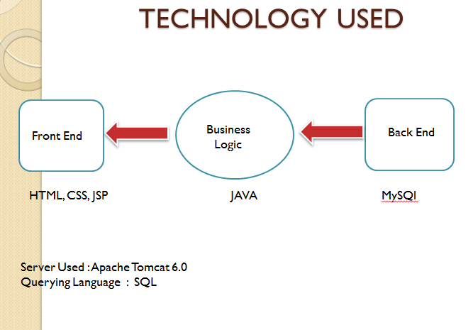

**Data table:**

1. **User table**

|  |  |  |  |
| --- | --- | --- | --- |
| Sr.no | Field name | Data Type | Description |
| 1. | Name | varchar | Store name of the user |
| 2. | Iduser* | Char | Store user name |
| 3. | Password | Varchar | Store password corresponding to username |
| 4. | Gender | Varchar | Gender of user |
| 5. | Address | Varchar | Address of user |
| 6. | Mobileno | Varchar | Mobile no of user |
| 7. | Emailed | Varchar | Email id of user |
| 8 | Type | Varchar | User is “student ” or “admin” |
| 9. | Security | Varchar | User have a security question |

**2.Question**

|  |  |  |  |
| --- | --- | --- | --- |
| Sr.no. | Field name | Data Type | Description |
| 1. | Questioned | Int* | It is a unique id for each Q. |
| 2. | Question | varchar | Question |
| 3. | A | Varchar | Option a |
| 4. | B | Varchar | Option b |
| 5. | C | Varchar | Option c |
| 6. | D | Varchar | Option d |
| 7. | Ans | Varchar | Answer of the question |
| 8. | Level | Varchar | Level of the question |
| 9. | Subject | Varchar | Subject from the question is |

**3. Schedule:**

|  |  |  |  |
| --- | --- | --- | --- |
| Sr.no. | Field name | Data Type | Description |
| 1. | Examid* | int | There is unique id for each exam |
| 2. | Date | Date | Date of exam |
| 3. | Time | Time | Time at which exam will start |
| 4. | Tlimit | Time | Time limit of exam |
| 5. | Level | Varchar | Level of exam |
| 6. | Subject | varchar | Subject of exam |
| 7. | Noq | Int | No of question |

**4.Exam_student:**

|  |  |  |  |
| --- | --- | --- | --- |
| Sr.no. | Field name | Data Type | Description |
| 1. | Examid* | Int | Examid related to a student |
| 2. | Iduser* | Char | Userid of user |
| 3. | Status | varchar | Status of the exam |

**Data flow diagram**

iduser

Exam_id

DESIGN:

|  |
| --- |
| LOGIN |

|  |
| --- |
| Student |

|  |
| --- |
| cancel |

|  |
| --- |
| Administer |

|  |
| --- |
| Register |

|  |
| --- |
| Account |

|  |
| --- |
| Register |

|  |
| --- |
| Question |

|  |
| --- |
| Schedule |

|  |
| --- |
| Add user |

**Schedule a exam**

**Cancel schedule**

**Screen shots of form**

**1.login**

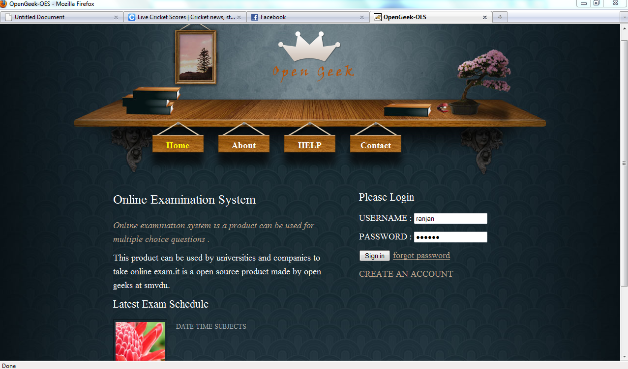

**2.ADMIN_HOME**

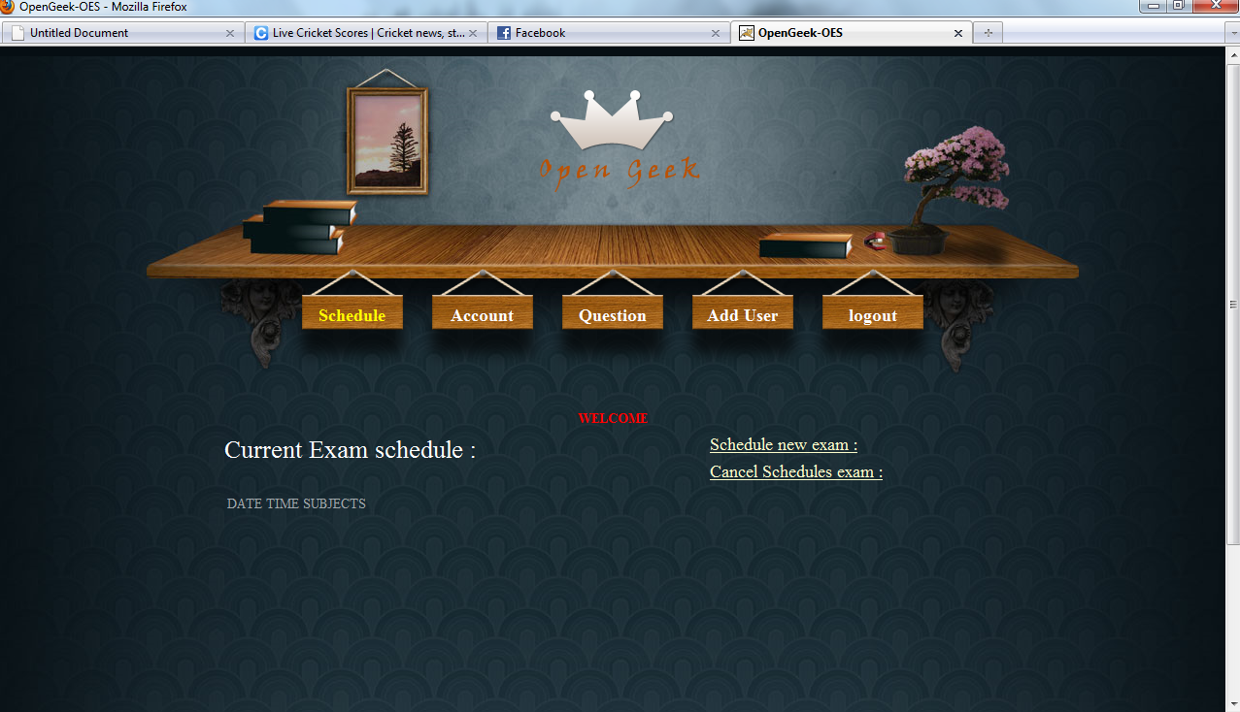

**3.admin_ACCOUNT**

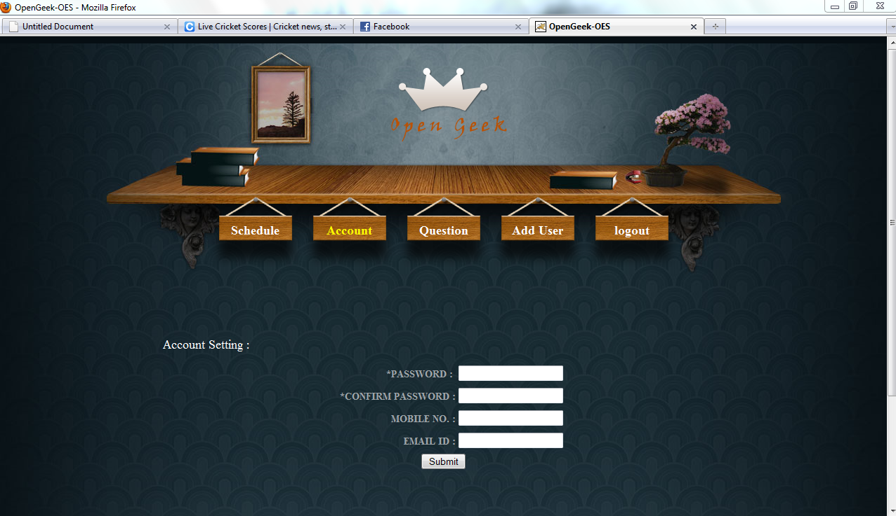

**4ADMIN_ADDQUESTION**

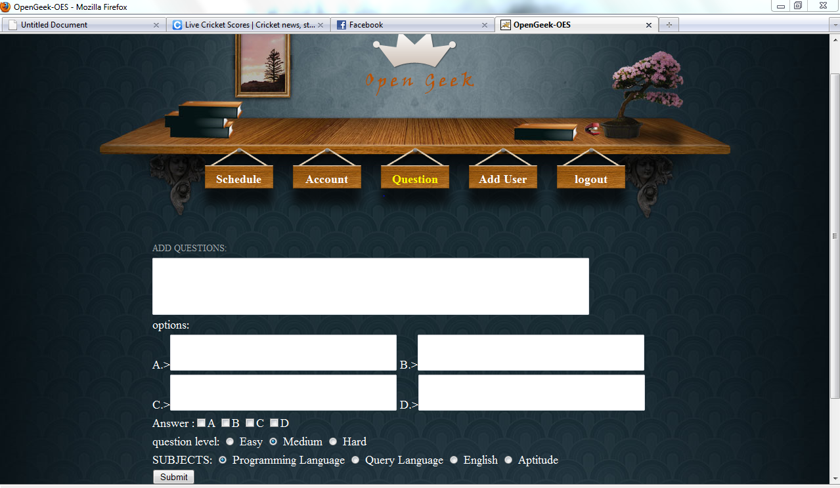

**5ADD_ADMIN**

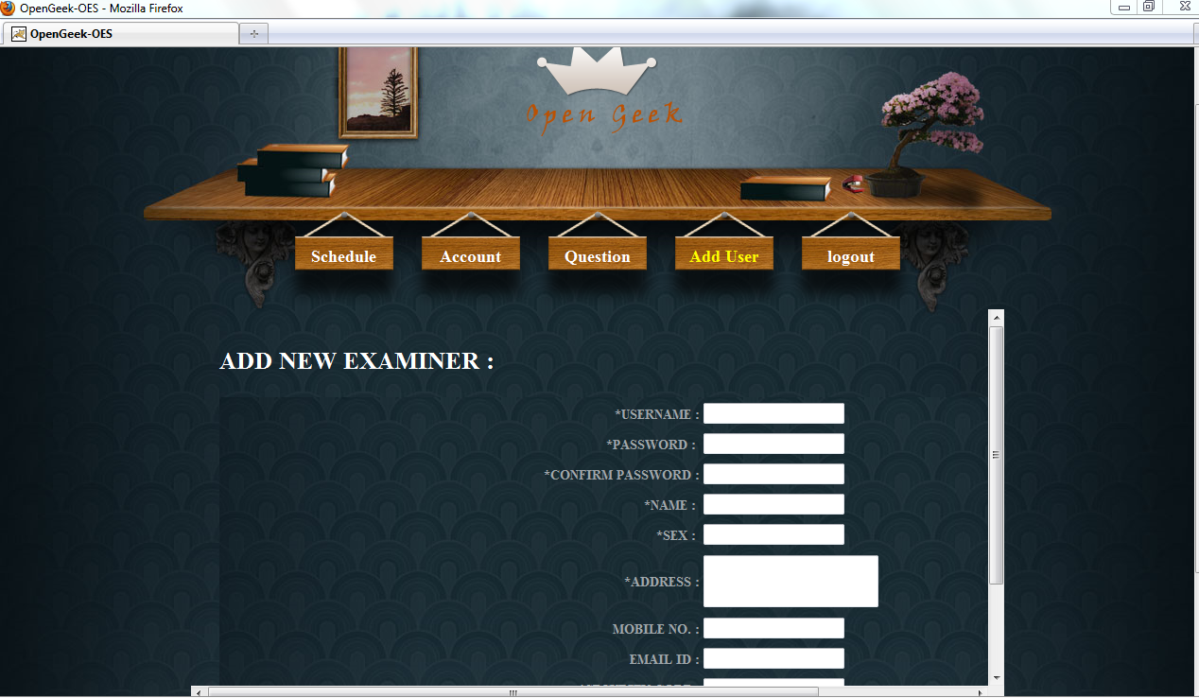

**6.SCHEDULE_NEW EXAM**

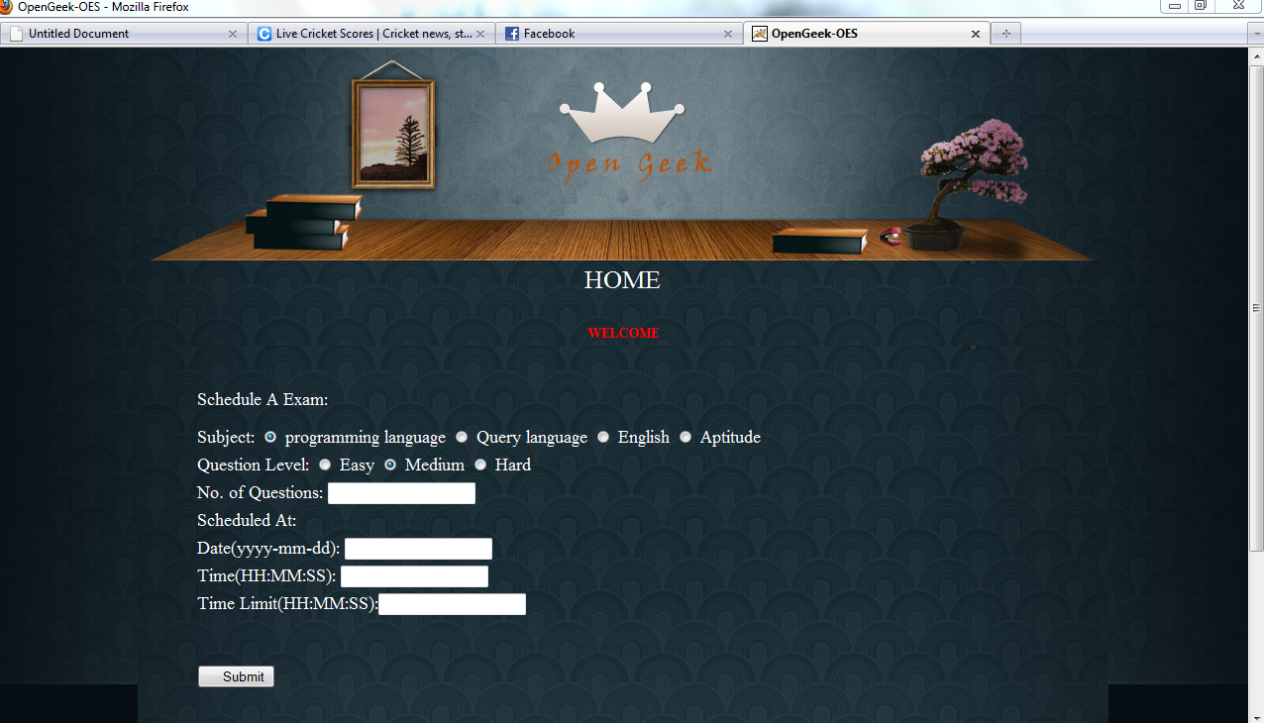

**7.CANCEL_SCHEDULE**

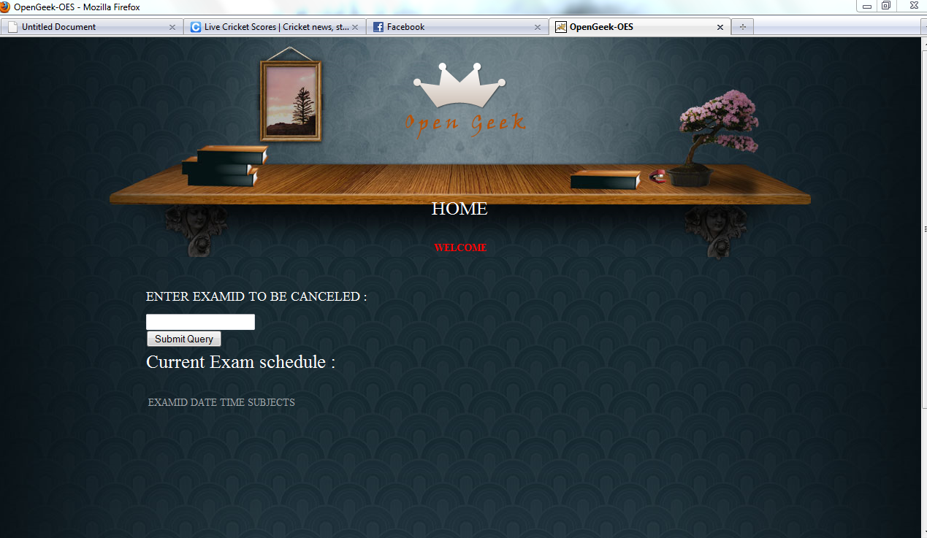

**8.STUDENT_HOME**

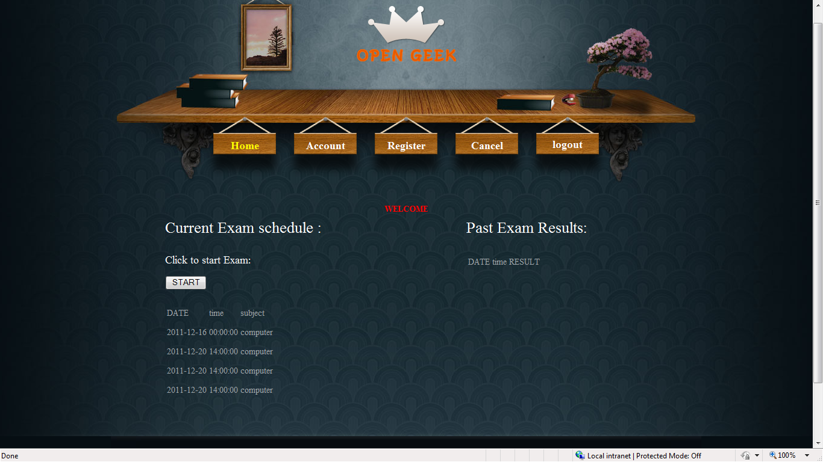

**9.STUDENT_ACCOUNT**

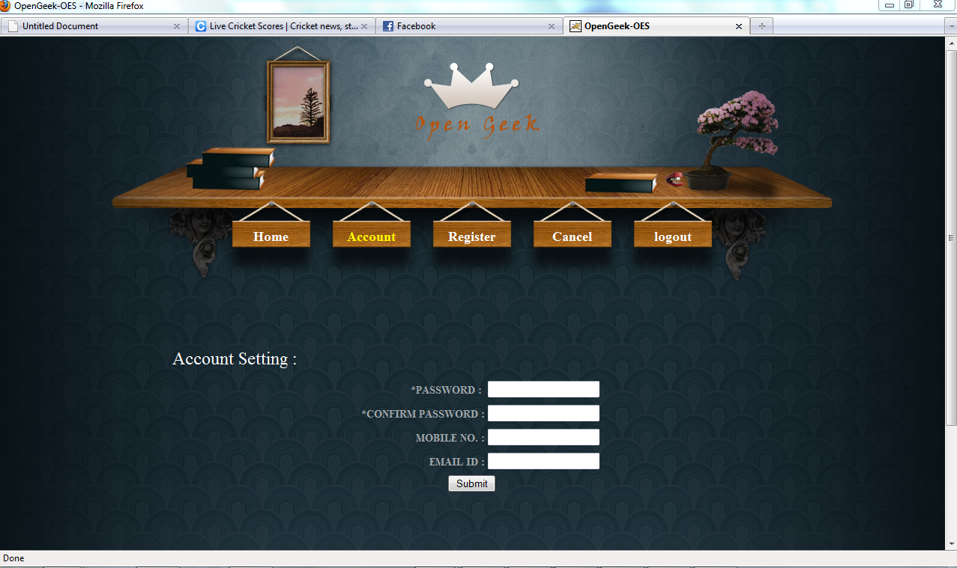

**10.REGISTER_STUDENT**

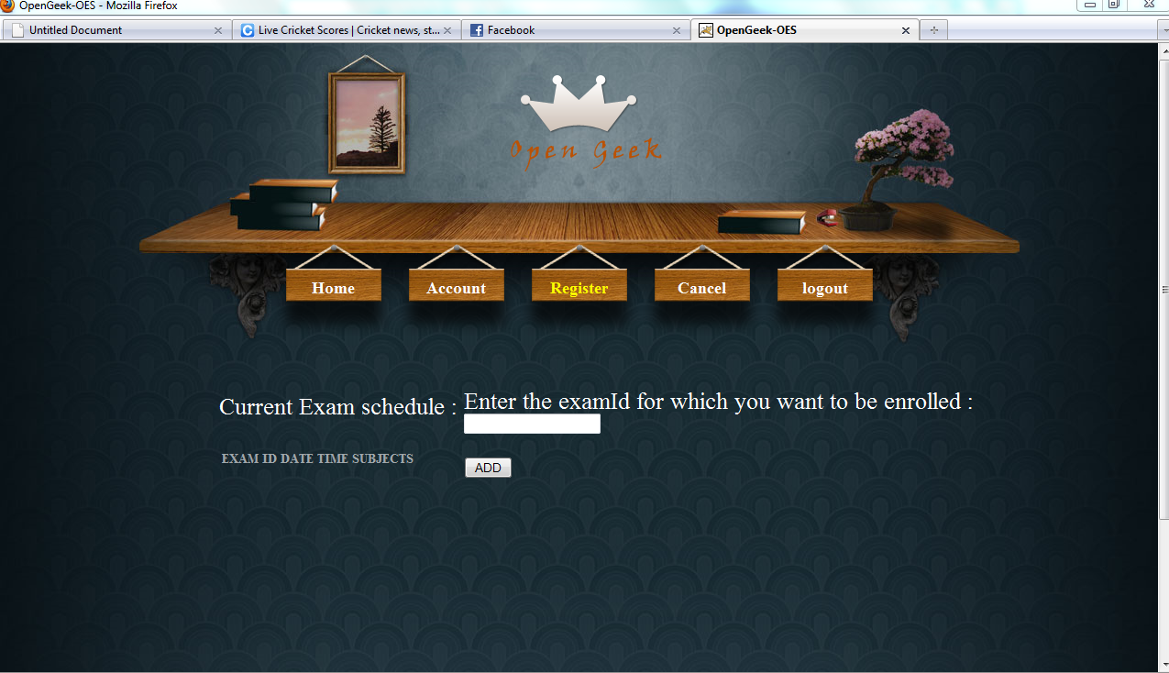

**11.CANCEL_EXAM_STUDENT**

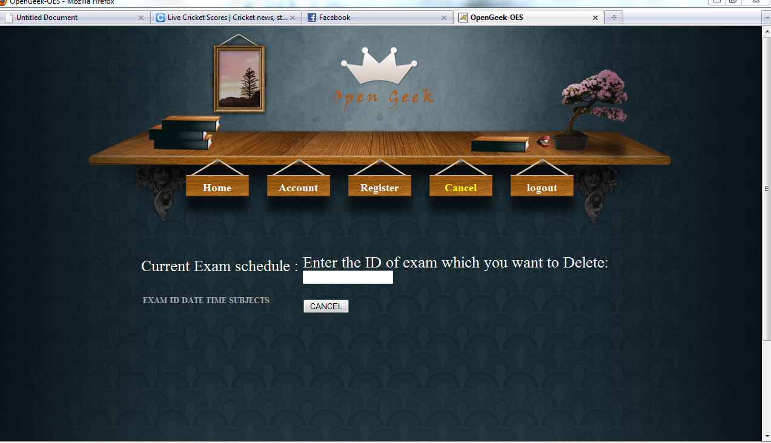

**Result:**

This project is very broad in terms of other manually taking exams.

Few of them are:-

* This can be used in educational institutions as well as in corporate

world.

* Can be used anywhere any time as it is a web based application(user location doesn’t matter).
* No restriction that examiner has to be present when the candidate

takes the test.

**CONCLUSION**

The On line test System is developed using Java and sql fully meets the objectives of the system for which it has been developed. The system has reached a steady state where all bugs have been eliminated. The system is operated at a high level of efficiency and all the teachers and user associated with the system understands its advantage. The system solves the problem. It was intended to solve as requirement specification.

**Future Scope:**

* The System can be enhanced to support other QA types like fill in the blanks, true/false, match the columns etc.
* The System can be enhanced by deploying it to the world wide web, so users can use System from distant places.
* There is proposition for adding an extra functionality for checking the Subjective answers to with this system.